**Lane Detection using Computer Vision for Self-Driving Cars**

Smartinternz Guided Project

Swetha Mudiga

18251A05G6

GNITS

**INDEX**

1. INTRODUCTION

1.1 Overview

1.2 Purpose

2. LITERATURE SURVEY

2.1 Existing problem

2.2 Proposed solution

3. FLOWCHART

4. METHODOLOGY

* 1. Architecture
  2. Project Objectives
  3. Project Flow
  4. Image Manipulation
  5. Feature Extraction

5. RESULT

6. LIMITATIONS

7. CONCLUSION

8. BIBILOGRAPHY

**1. INTRODUCTION**

1.1 Overview

Lane detection is a critical component of self-driving cars and autonomous vehicles. Once lane positions are obtained, the vehicle will know where to go and avoid the risk of running into other lanes or getting off the road. This can prevent the driver/car system from drifting off the driving lane. There are multiple ways we can perform lane detection. We can use the learning-based approaches, such as training a deep learning model, However, there are simpler methods to perform lane detection as well. In this project, we are detecting lanes using Computer Vision with the popular OpenCV library in python.

1.2 Purpose

For vehicles to be able to drive by themselves, they need to understand their surrounding world like human drivers, so they can navigate their way in streets, pause at stop signs and traffic lights, and avoid hitting obstacles such as other cars and pedestrians. Based on the problems encountered in detecting objects by autonomous vehicles an effort has been made to demonstrate lane detection using OpenCV library. The procedure of detecting edges in an image, selecting region of interest and choosing polar coordinates has been discussed.

**2. LITERATURE SURVEY**

2.1 Existing problem

During the driving operation, humans use their optical vision for vehicle manoeuvring. The road lane marking, act as a constant reference for vehicle navigation. One of the prerequisites to have in a self-driving car is the development of an Automatic Lane Detection system using an algorithm.

2.2 Proposed solution

Computer vision is a technology that can enable cars to make sense of their surroundings. It is a branch of artificial intelligence that enables software to understand the content of image and video. Modern computer vision has come a long way due to the advances in deep learning, which enables it to recognize different objects in images by examining and comparing millions of examples and cleaning the visual patterns that define each object.

**3. FLOWCHART**

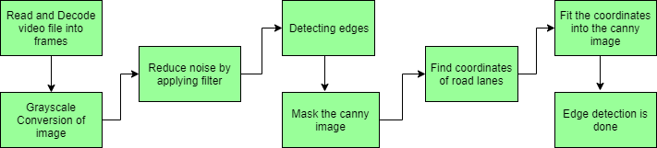

**4. METHODOLOGY**

4.1 Architecture

The project involves detection of lane lines in an image using Python and OpenCV. OpenCV means “Open-Source Computer Vision”, which is a package that has many useful tools for analyzing images.

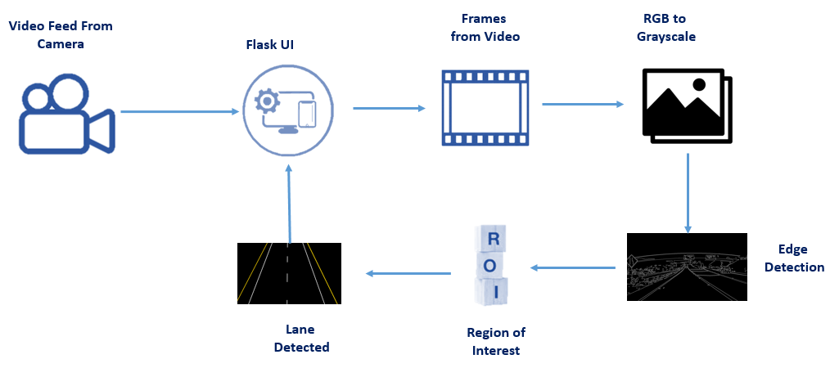

* 1. Project Objectives
* To build a flask application which takes input a video and detects lanes on a road.
* To Use Computer Vision functions and operations to a great extent.
* To build and integrate a web application using the Flask framework.
  1. Project Flow
* Capturing and decoding video file frame by frame
* Conversion of the Image to Grayscale for accuracy and speed.
* Applying filters to reduce noise in video frames.
* Edge Detection Using Canny Edge detection method
* Finding the region of interest and working on that part.
* Detecting lanes using Computer Vision Wrapping Technique.

4.4 Image Manipulation

* Process Image Function:

Convert image to grayscale: cvtColor: bgr to hls: In case of 8-bit and 16-bit images, R, G and B are converted to the floating-point format and scaled to fit the 0 to 1 range, apply threshold, blur & extract edges, lower white and upper white are boundaries.

This result uses Bitwise and that deals with image manipulation and used for extracting essential parts in the image

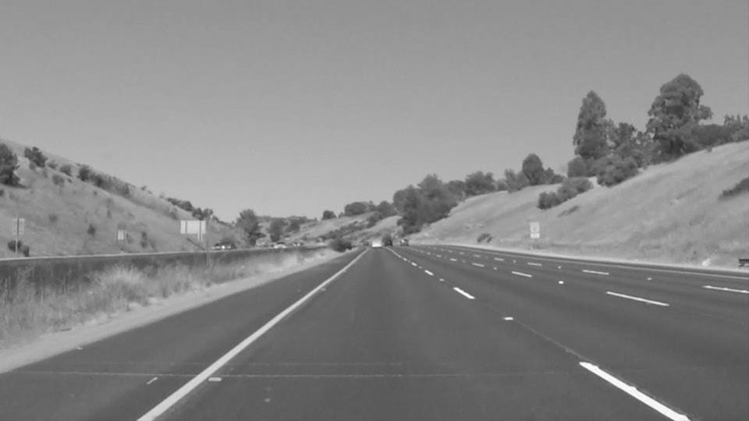

.

* Birds Eye view:

A bird's-eye view is an elevated view of an object from above, with a perspective as though the observer were a bird, often used in the making of blueprints, floor plans, and maps.

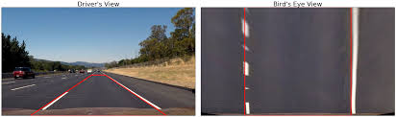

* Visualization:

It is used to enhance the learning Technique by picturising the data after every step. In that way you will have a pictorial or graphical understanding of data as well as working procedure.

4.5 Feature Extraction

* Slide window-search:

In this Activity, we Store all the Data into Stack, With the values obtained with the help of bird's Eye view and Histogram. Fit Curves shows the curve that best fits a set of coordinate plane points.

* Measure-lane-curvature:
* Reverse to match top-to-bottom values of X and Y
* Choose the maximum y-value, corresponding to the bottom of the image
* Fit new polynomials to x, y in world space
* Check for new inputs radii
* Decide if it is a left or a right curve
* Off Center

If something is off-center, it is not exactly in the middle of a space or surface.

Calculating deviation in meters using Mean Values.  Pixel deviation using Input shape and Absolute Value

* Draw Lane Lines
* Drawing info of left, right, left_fit, right_fit and ploty function
* Add Wrap Perspective and weights for Original Image.
* Add Text
* Add the radius and center position to the image
* Show Radius, Direction, Offcenter and More

5. RESULT

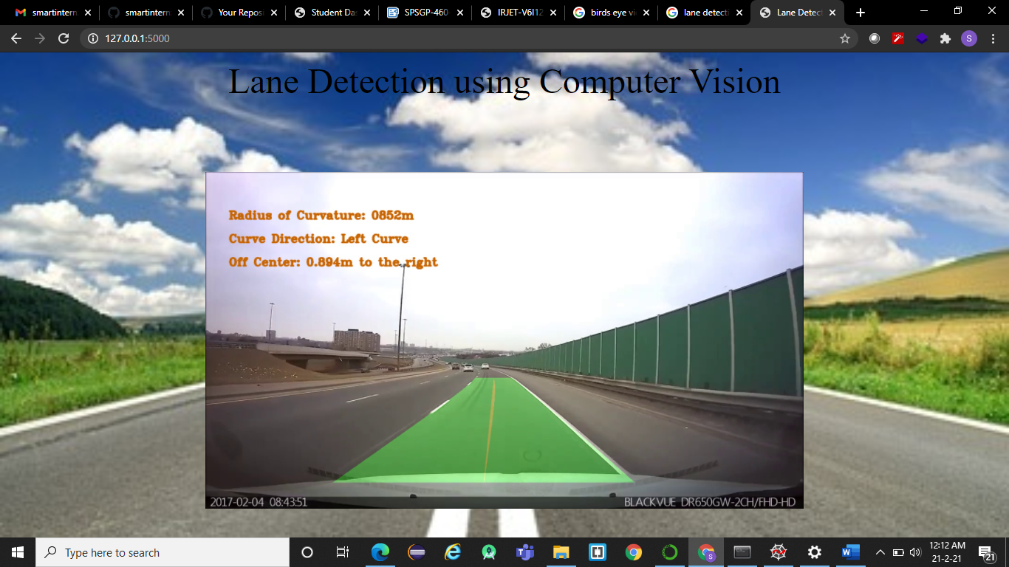

6. Limitations

Modern computer vision has come a long way due to the advances in deep learning, which enables it to recognize different objects in images by examining and comparing millions of examples and cleaning the visual patterns that define each object.

While especially efficient for classification tasks, deep learning suffers from serious limitations and can fail in unpredictable ways. This means that a driverless car might crash into a truck in broad daylight, or worse, accidentally hit a pedestrian. The current computer vision technology used in autonomous vehicles is also vulnerable to adversarial attacks, by manipulating the AI’s input channels to force it to make mistakes. For instance, researchers have shown they can trick a self-driving car to avoid recognizing stop signs by sticking black and white labels on them

7. CONCLUSION

Computer vision is a technology that can enable cars to make sense of their surroundings. It is a branch of artificial intelligence that enables software to understand the content of image and video. In the methodology, we made use of the OpenCV library and its functions such as the Canny Function through which we achieved edge detection. Then we prepared a mask of zero intensity and mapped our region of interest by performing the bitwise operation. Then we used the techniques that detected the straight lines in the image and identified the lane lines.

8. BIBILOGRAPHY

* <https://www.irjet.net/archives/V6/i1/IRJET-V6I1245.pdf>
* <https://data-flair.training/blogs/road-lane-line-detection>
* <https://machinelearningmastery.com/what-is-computer-vision>
* <https://en.wikipedia.org/wiki/Line_detection>